**lSetup for development**

1. setup mysql, ember 2, tomcat 7, git (tortoise git preferred)
2. UI/notes has ember project
3. Git will use ssh with private key. (git help <https://docs.google.com/document/d/1xdFmYG4h8j0XQmP4QE4jJPP_Ap_904Fdkko4pTqpzt4/edit?usp=drive_web>)
4. Download from git to a local folder. Lets call folder “AllSchool” .Create mysql database “notes” without root password
5. Run project on tomcat 7. Change root url to “/” . Project should be accessible at localhost:8080
6. Setup ember at AllSchool/UI/notes and install dependencies.
7. Run ember with [ **ember server --proxy** [**http://**](http://127.0.0.1:8080)**localhost**[**:8080**](http://127.0.0.1:8080) ] . All rest calls will be redirected to tomcat server and UI files will be served by ember server at [http://](http://127.0.0.1:8080)localhost:4200
8. [ember build --environment=production] will generate final html/ css files. Copy all files in AllSchool/UI/notes/dist and paste in AllSchool/WebContent . restart tomcat server and you can see code at [http://](http://127.0.0.1:8080)localhost[:8080](http://127.0.0.1:8080)

Tomcat setup :

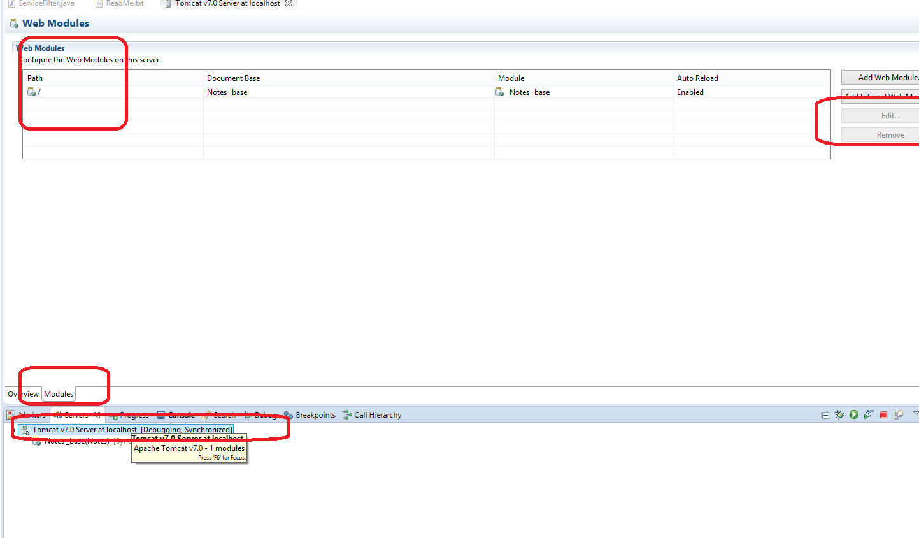

**For first run / test :**

for first time testing :

Create mysql database “notes” without root password

build ember project in UI/notes with

**ember build --environment=production**

copy files from UI/notes/dist to WebContent (replace existing files).

run on tomcat

change path to "/"

Restart tomcat and visit localhost:8080